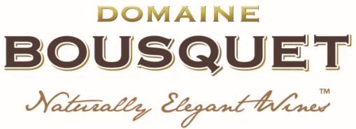

Domaine Bousquet Debuts Uco Valley Reserve Cabernet Franc

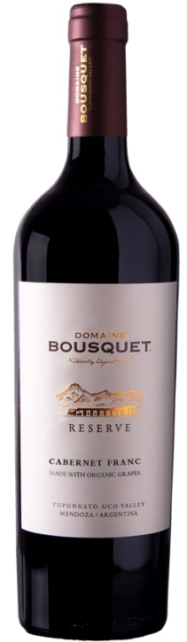
Miami, FL, Dec. 6, 2021: Starting this month, Domaine Bousquet, Argentina’s largest producer and exporter of certified organic wines, is introducing a new Uco Valley Reserve Cabernet Franc to the U.S. The debut 2020-vintage Domaine Bousquet Reserve Cabernet Franc joins an existing line of Reserve-designated varietals comprising a Chardonnay, Cabernet Sauvignon, Malbec, and Pinot Noir, all line-priced at $18 and 100% certified organic.

“The high-altitude vineyards of the Uco Valley, especially in Gualtallary, have become the epicenter of superb quality Cabernet Franc with a distinctive style that has the potential to become a benchmark for this grape variety, joining the classics from the Loire and Bordeaux.”
Anne Bousquet, co-owner. Domaine Bousquet

Domaine Bousquet’s vineyards are among the highest in Gualtallary. A 4,000-foot elevation ensures that grapes here offer more aroma and body, while preserving food-friendly acidity. The wine has the savory characteristics beloved by Cabernet Franc fans, without the variety’s occasional green/leafy notes thanks to the area’s ample/intense sunlight. The wine is aged six months in French oak.

Domaine Bousquet Reserve Cabernet Franc 2020 (New to Market)
Domaine Bousquet Reserve Chardonnay 2020
Domaine Bousquet Reserve Cabernet Sauvignon 2020
Domaine Bousquet Reserve Malbec 2020
Domaine Bousquet Reserve Pinot Noir 2020

Line priced: $18 SRP
Available CA, CT, DC, DE, IL, KY, MA, MD, NJ, NY, OR, RI, VT and WA
Imported by Origins Organic, Miami, FL
Bottle shot + tech sheet attached

Media Contact:
Jane Kettlewell
Creative Palate Communications
718-704-4041 / Jane@CPalate.com

Domaine Bousquet, owned and run by husband-and-wife team Labid al Ameri and Anne Bousquet, has made a name for itself in the organic category in a relatively short period, beginning with the 2005 release of the winery’s first vintage. The 672-acre estate in Gualtallary, a sub-zone of Tupungato in Mendoza’s Uco Valley, is now Argentina’s largest producer and exporter of certified organic wines. Vineyards planted in virgin terrain, starting in the late 1990s, lie at a dizzying altitude of 4,000+ feet. True to its owners’ European heritage, the wines are crafted with a French winemaking sensibility.

